Week – 6

TASK -1
AIM :
To calculate the string similarity of a given string by finding the sum of the lengths of the longest common prefixes between the string and each of its suffixes using the Z-algorithm.

ALGORITHM:
- Read the number of test cases t.
- For each test case, read the input string s.
- Let n be the length of the string and create an array Z of size n.
- Initialize sum = n because the string is always identical to itself.
- Initialize two pointers left = 0 and right = 0.
- Traverse the string from index 1 to n-1.
- If the current index is within the window [left, right], copy the previously computed value from the Z array.
- Compare characters of the prefix with the substring starting at the current index and increase Z[i] while they match.
- If the new match extends beyond right, update left and right.
- Add Z[i] to sum.
- After processing all suffixes, return sum.
PROGRAM :
import java.util.*;
public class Solution
public long stringSimilarity(String s) {
int n = s.length();
int[] Z = new int[n];
long sum = n;
int left = 0, right = 0;
for (int i = 1; i < n; i++) {

if (i <= right) {
Z[i] = Math.min(right - i + 1, Z[i - left]);
}
while (i + Z[i] < n && s.charAt(Z[i]) == s.charAt(i + Z[i])) {
Z[i]++;
}
if (i + Z[i] - 1 > right) {
left = i;
right = i + Z[i] - 1;
}
sum += Z[i];
}
return sum;
}
public static void main(String[] args) {
Scanner sc = new Scanner(System.in);
int t = Integer.parseInt(sc.nextLine().trim());
Solution sol = new Solution();

for (int i = 0; i < t; i++) {
String s = sc.nextLine().trim();
System.out.println(sol.stringSimilarity(s));
}
sc.close();
}
}

OUTPUT :
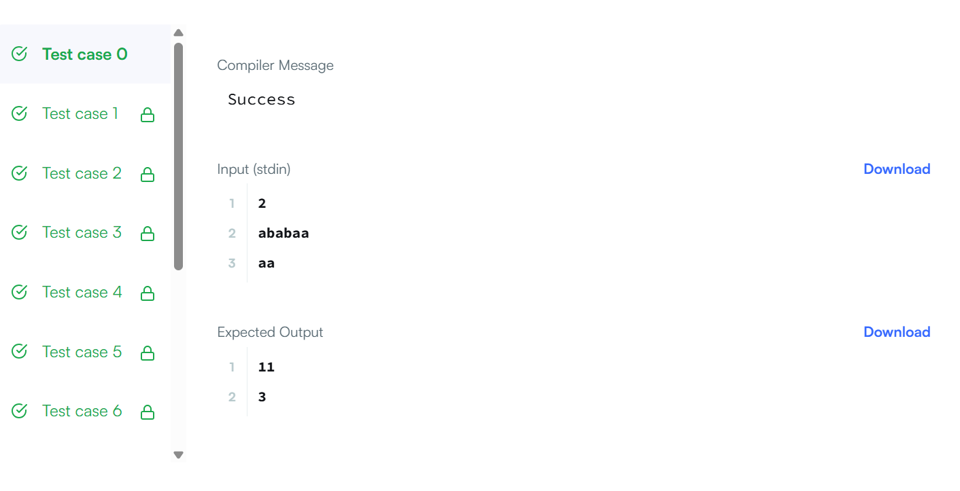

RESULT :
The program successfully computes and prints the total string similarity by summing the lengths of the longest common prefixes between the given string and all its suffixes for each test case.

TASK – 2
AIM :
To write a Java program to check whether a given string is formed by repeating one of its substrings.
Algorithm :
- Start the program.
- Take the input string s.
- Create a new string by concatenating the string with itself (s + s).
- Remove the first and last characters of the new string.
- Check if the original string exists inside the modified string.
- If it exists, return true (repeated substring pattern).
- Otherwise, return false.
- Stop the program.

PROGRAM :

public class Solution {
public boolean repeatedSubstringPattern(String s) {
String doubled = s + s;
return doubled.substring(1, doubled.length() - 1).contains(s);
}
public static void main(String[] args) {
Solution sol = new Solution();
System.out.println(sol.repeatedSubstringPattern("abab"));
System.out.println(sol.repeatedSubstringPattern("aba"));
System.out.println(sol.repeatedSubstringPattern("abcabcabcabc"));

}
}
OUTPUT :
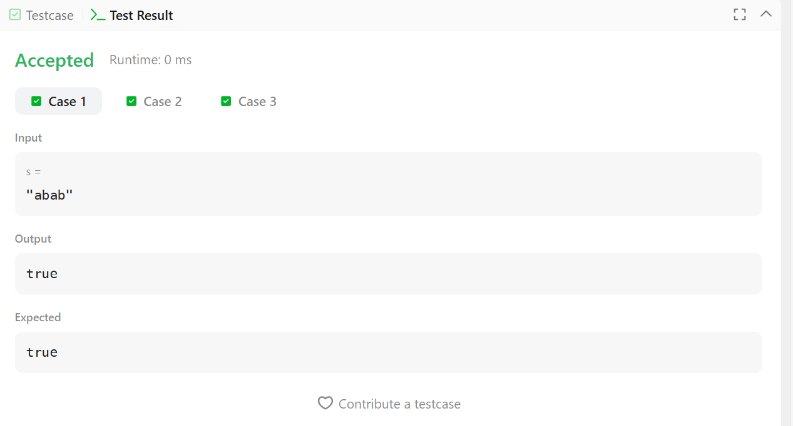

RESULT :
The program successfully checks whether the given string contains a repeated substring pattern and prints true or false as the output.

TASK - 3
AIM :
To write a Java program to check whether two strings share at least one common character.
Algorithm :
- Start the program.
- Read two input strings s1 and s2.
- Store all characters of s1 in a HashSet.
- Traverse each character of s2.
- Check if the character exists in the set.
- If found, return "YES".
- If no common character is found after checking all characters, return "NO".
- Print the result.

PROGRAM :
import java.util.*;
public class Solution {
public static String twoStrings(String s1, String s2) {
// Use a set to store characters of s1
Set<Character> set = new HashSet<>();
for (char c : s1.toCharArray()) {
set.add(c);
}

// Check if any character of s2 exists in s1
for (char c : s2.toCharArray()) {
if (set.contains(c)) {
return "YES";
}
}
return "NO";
}

public static void main(String[] args) {
Scanner sc = new Scanner(System.in);
int t = Integer.parseInt(sc.nextLine().trim());

for (int i = 0; i < t; i++) {
String s1 = sc.nextLine().trim();
String s2 = sc.nextLine().trim();
System.out.println(twoStrings(s1, s2));
}
sc.close();
}
}

OUTPUT :
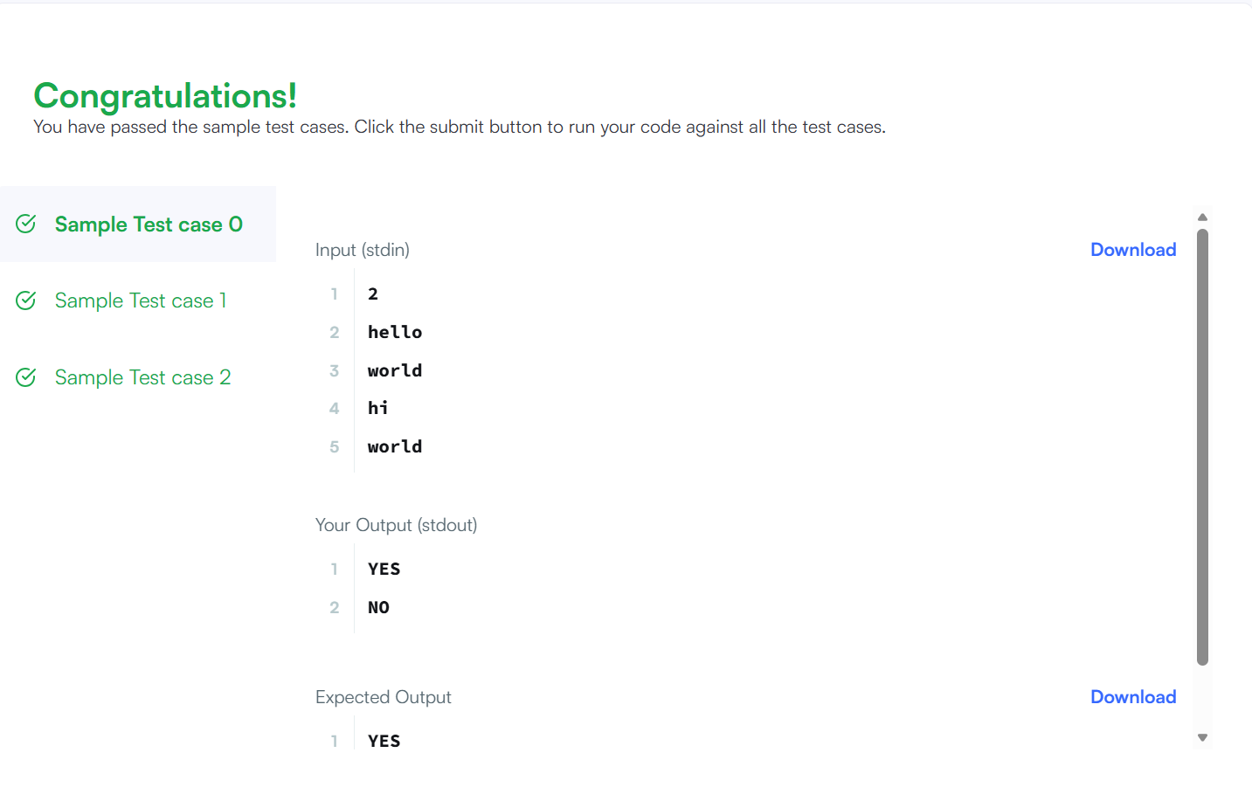

RESULT :
The program successfully checks whether two strings have at least one common character and prints "YES" if they share a character, otherwise "NO".

TASK – 4
AIM :
To write a Java program to check whether one string can be obtained by rotating another string.
Algorithm :
- Start the program.
- Take two strings s and goal.
- Check if the lengths of both strings are equal.
- If lengths are not equal, return false.
- Concatenate the string with itself (s + s).
- Check if the goal string exists inside the concatenated string.
- If it exists, return true (rotation possible).
- Otherwise, return false.
- Stop the program.
PROGRAM :
class Solution {
public boolean rotateString(String s, String goal) {
if (s.length() != goal.length()) {
return false;
}
String doubled = s + s;
return doubled.contains(goal);
}
}

OUTPUT :

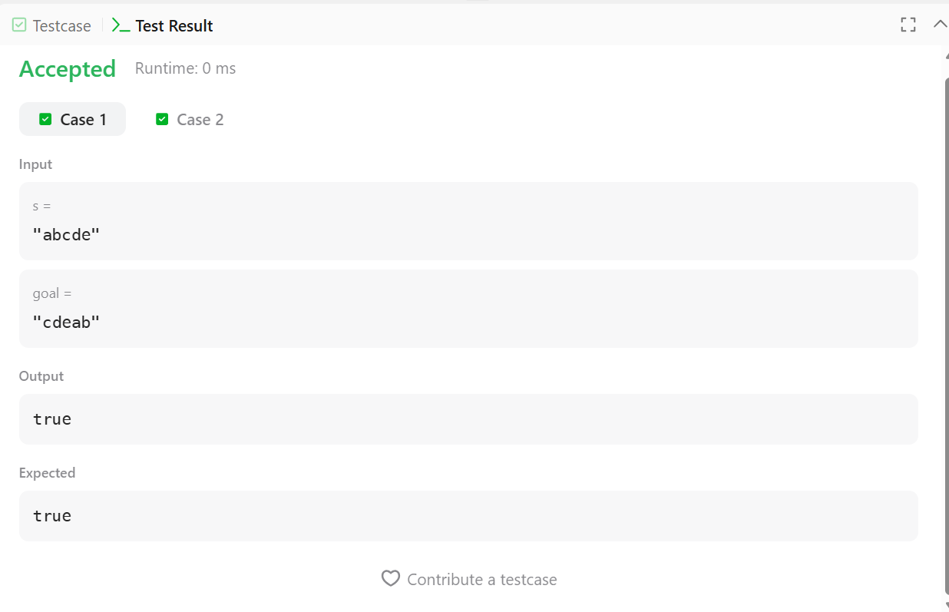

RESULT :
The program checks whether the goal string is a rotation of the original string and returns true or false as the output.

TASK 5 :
AIM :
To write a Java program to determine the number of altered characters in a message received from Mars where the original signal should be "SOS" repeated.
Algorithm :
- Start the program.
- Read the input string s.
- Set a variable changes = 0.
- Compare each character of the string with the expected pattern "SOS".
- If the character does not match the expected character, increment changes.
- Continue until the end of the string.
- Return the total number of changes.
- Print the result.

PROGRAM :
import java.util.Scanner;
class Solution {
public static int marsExploration(String s) {
int changes = 0;
String expected = "SOS";
for (int i = 0; i < s.length(); i++) {
if (s.charAt(i) != expected.charAt(i % 3)) {
changes++;
}
}

return changes;
}
public static void main(String[] args) {
Scanner sc = new Scanner(System.in);
String s = sc.nextLine();
sc.close();

int result = marsExploration(s);
System.out.println(result);
}
}

OUTPUT :
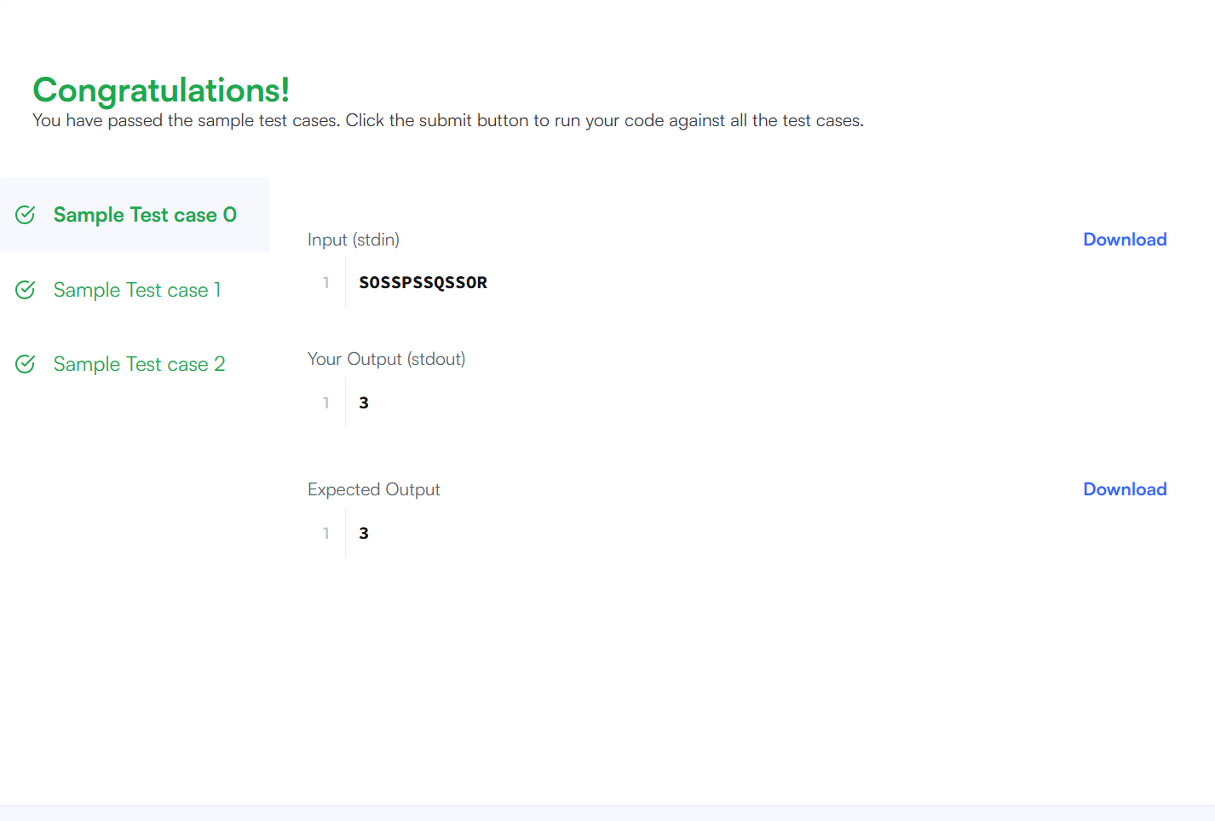

RESULT :
The program successfully calculates and prints the number of characters altered in the SOS message received from Mars.

TASK 6 :
AIM :
To write a Java program to find all starting indices of anagrams of string p in string s.
Algorithm :
- Start the program.
- Create two frequency arrays of size 26 for characters of p and the current window of s.
- Count the frequency of characters for p and the first window of s.
- Compare both frequency arrays. If equal, add index 0 to the result.
- Slide the window through s by adding the next character and removing the previous one.
- After each slide, compare the frequency arrays.
- If equal, add the starting index to the result list.
- Return and print the list of indices.
PROGRAM :
import java.util.*;
class Solution {
public List<Integer> findAnagrams(String s, String p) {
List<Integer> result = new ArrayList<>();
if (s.length() < p.length()) return result;
int[] pCount = new int[26];
int[] sCount = new int[26];
for (int i = 0; i < p.length(); i++) {
pCount[p.charAt(i) - 'a']++;
sCount[s.charAt(i) - 'a']++;
}
if (Arrays.equals(pCount, sCount)) {
result.add(0);
}

for (int i = p.length(); i < s.length(); i++) {
sCount[s.charAt(i) - 'a']++;
sCount[s.charAt(i - p.length()) - 'a']--;
if (Arrays.equals(pCount, sCount)) {
result.add(i - p.length() + 1);
}
}
return result;
}
public static void main(String[] args) {
Solution sol = new Solution();
System.out.println(sol.findAnagrams("cbaebabacd", "abc"));
System.out.println(sol.findAnagrams("abab", "ab"));
}
}

OUTPUT :
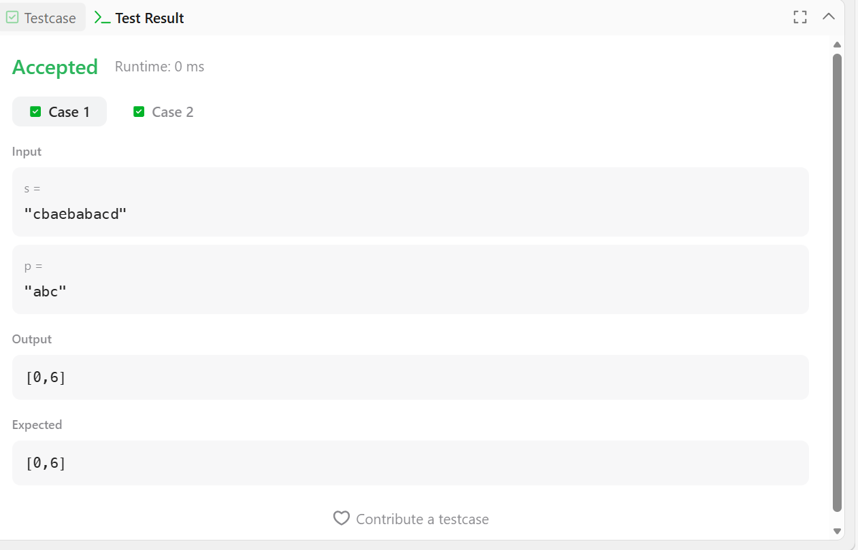

RESULT :
The program successfully finds and prints the starting indices of all anagrams of p present in string s.

TASK 7 :
AIM :
To write a Java program to find the index of a character which, when removed, makes the string a palindrome.
Algorithm :
- Start the program.
- Read the input string s.
- Set two pointers: left = 0 and right = length − 1.
- Compare characters at left and right.
- If they are equal, move left++ and right--.
- If they are not equal:
  - Check if removing the left character makes the substring a palindrome.
  - If yes, return left.
  - Otherwise check if removing the right character makes it a palindrome.
  - If yes, return right.
- If the string is already a palindrome, return -1.
- Print the result.
PROGRAM :
import java.util.*;
class Solution {
// Function to check if a string is palindrome between two indices
private static boolean isPalindrome(String s, int left, int right) {
while (left < right) {
if (s.charAt(left) != s.charAt(right)) {
return false;
}
left++;
right--;
}
return true;
}
public static int palindromeIndex(String s) {
int left = 0;
int right = s.length() - 1;

while (left < right) {
if (s.charAt(left) != s.charAt(right)) {
// Try removing left character
if (isPalindrome(s, left + 1, right)) {
return left;
}
// Try removing right character
if (isPalindrome(s, left, right - 1)) {
return right;
}
// No solution
return -1;
}
left++;
right--;
}
// Already a palindrome
return -1;
}

public static void main(String[] args) {
Scanner sc = new Scanner(System.in);
int q = sc.nextInt(); // number of queries
sc.nextLine(); // consume newline
for (int i = 0; i < q; i++) {
String s = sc.nextLine();
System.out.println(palindromeIndex(s));
}
sc.close();
}
}
OUTPUT :
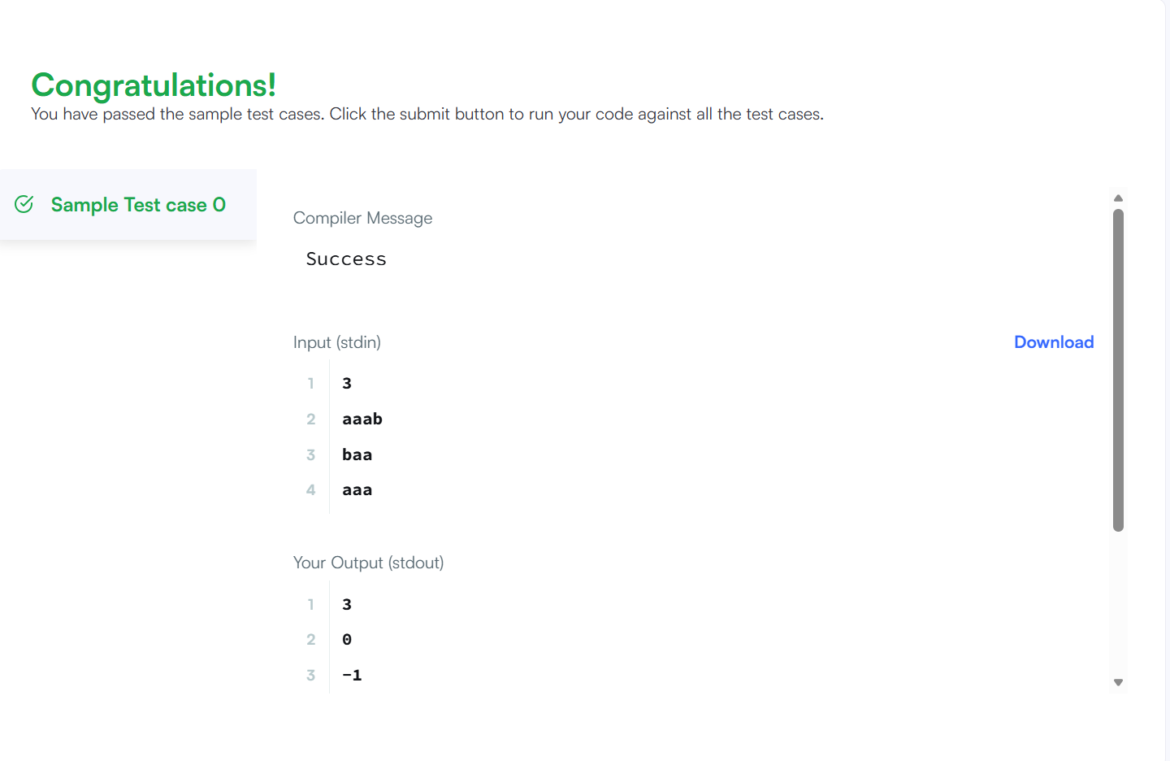

RESULT :
The program successfully prints the index of the character whose removal makes the string a palindrome, or -1 if the string is already a palindrome.

TASK 8 :
AIM :
To write a program to find the index of the first occurrence of the string needle in the string haystack. If needle is not present, return -1.
Algorithm :
- Start the program.
- Take two input strings: haystack and needle.
- Traverse the haystack string from index 0 to haystack.length() - needle.length().
- At each position, compare the substring of haystack with needle.
- If both strings match, return the current index.
- If no match is found after checking all positions, return -1.
- Print the result.
PROGRAM :
class Solution {
public int strStr(String haystack, String needle) {
if (needle.isEmpty()) {
return 0;
}
int n = haystack.length();
int m = needle.length();
for (int i = 0; i <= n - m; i++) {
if (haystack.substring(i, i + m).equals(needle)) {
return i;
}
}
return -1;

}
public static void main(String[] args) {
Solution sol = new Solution();
System.out.println(sol.strStr("sadbutsad", "sad"));
System.out.println(sol.strStr("leetcode", "leeto"));
}
}

OUTPUT :
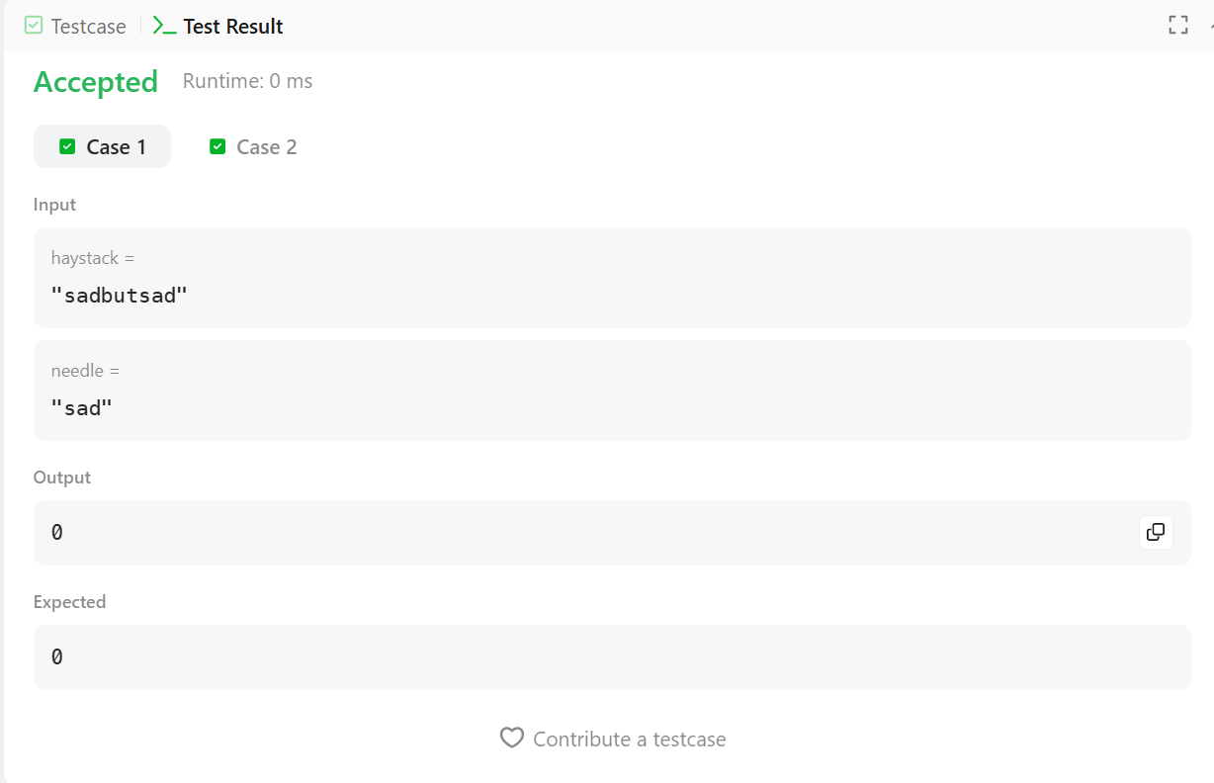

RESULT :
The program successfully returns the index of the first occurrence of needle in haystack, or -1 if the substring is not found.

TASK 9 :
AIM :
To write a Java program to find the longest palindromic substring in a given string.
Algorithm :
- Start the program.
- Input a string s.
- Initialize two variables start and end to store the palindrome boundaries.
- Traverse each character in the string as the center of the palindrome.
- For every index i, check two cases:
  - Odd length palindrome using (i, i)
  - Even length palindrome using (i, i + 1)
- Expand from the center while characters on both sides are equal.
- Calculate the palindrome length and update start and end if a longer palindrome is found.
- After checking all centers, extract the substring from start to end.
- Print the longest palindromic substring.
- Stop the program.
Program :
class Solution {
public String longestPalindrome(String s) {
if (s == null || s.length() < 1) return "";
int start = 0, end = 0;
for (int i = 0; i < s.length(); i++) {
int len1 = expandAroundCenter(s, i, i);
int len2 = expandAroundCenter(s, i, i + 1);
int len = Math.max(len1, len2);

if (len > end - start) {
start = i - (len - 1) / 2;
end = i + len / 2;
}
}

return s.substring(start, end + 1);
}
private int expandAroundCenter(String s, int left, int right) {
while (left >= 0 && right < s.length() && s.charAt(left) == s.charAt(right)) {
left--;
right++;
}
return right - left - 1;
}
public static void main(String[] args) {
Solution sol = new Solution();
System.out.println(sol.longestPalindrome("babad"));
System.out.println(sol.longestPalindrome("cbbd"));
}
}

OUTPUT :
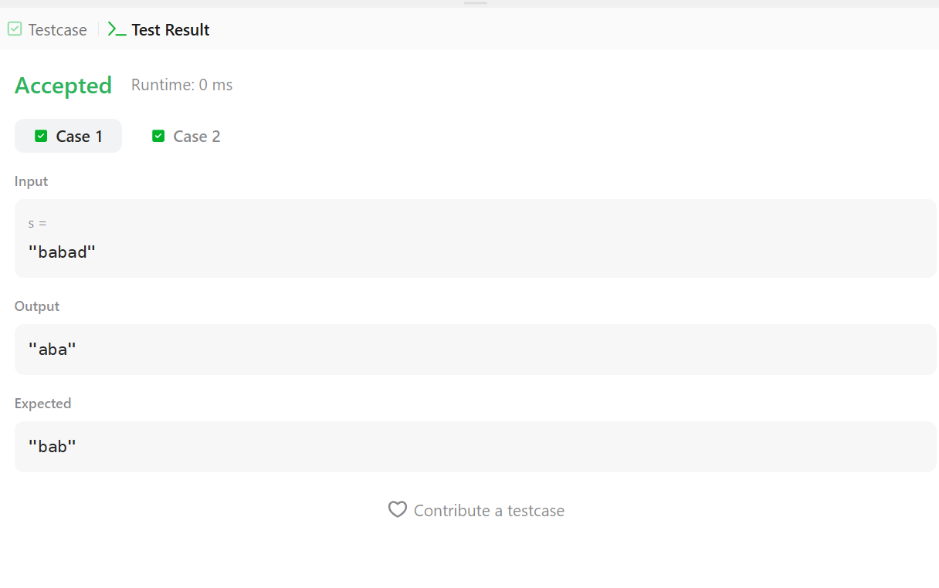

RESULT :
The program successfully finds and prints the longest palindromic substring from the given string.

TASK 10 :
AIM :
To write a Java program to find the length of the longest palindromic substring for each rotation of a given string.
Algorithm :
- Start the program.
- Input an integer n and a string s.
- For each rotation i from 0 to n-1:
  - Rotate the string using s.substring(i) + s.substring(0, i).
- For the rotated string, find the longest palindromic substring:
  - Take each character as the center.
  - Expand left and right to check odd length palindrome.
  - Expand left and right to check even length palindrome.
  - Update the maximum length found.
- Print the maximum palindrome length for each rotation.
- Repeat until all rotations are checked.
- Stop the program.
PROGRAM :
import java.util.*;
public class PalindromeRotation {
private static int longestPalindrome(String s) {
int n = s.length();
int maxLen = 1;
for (int center = 0; center < n; center++) {
int l = center, r = center;
while (l >= 0 && r < n && s.charAt(l) == s.charAt(r)) {
maxLen = Math.max(maxLen, r - l + 1);
l--; r++;

}
l = center; r = center + 1;
while (l >= 0 && r < n && s.charAt(l) == s.charAt(r)) {
maxLen = Math.max(maxLen, r - l + 1);
l--; r++;
}
}
return maxLen;
}
public static void main(String[] args) {
Scanner sc = new Scanner(System.in);
int n = Integer.parseInt(sc.nextLine().trim());
String s = sc.nextLine().trim();
for (int i = 0; i < n; i++) {
String rotated = s.substring(i) + s.substring(0, i);
System.out.println(longestPalindrome(rotated));
}
sc.close();
}
}

OUTPUT :

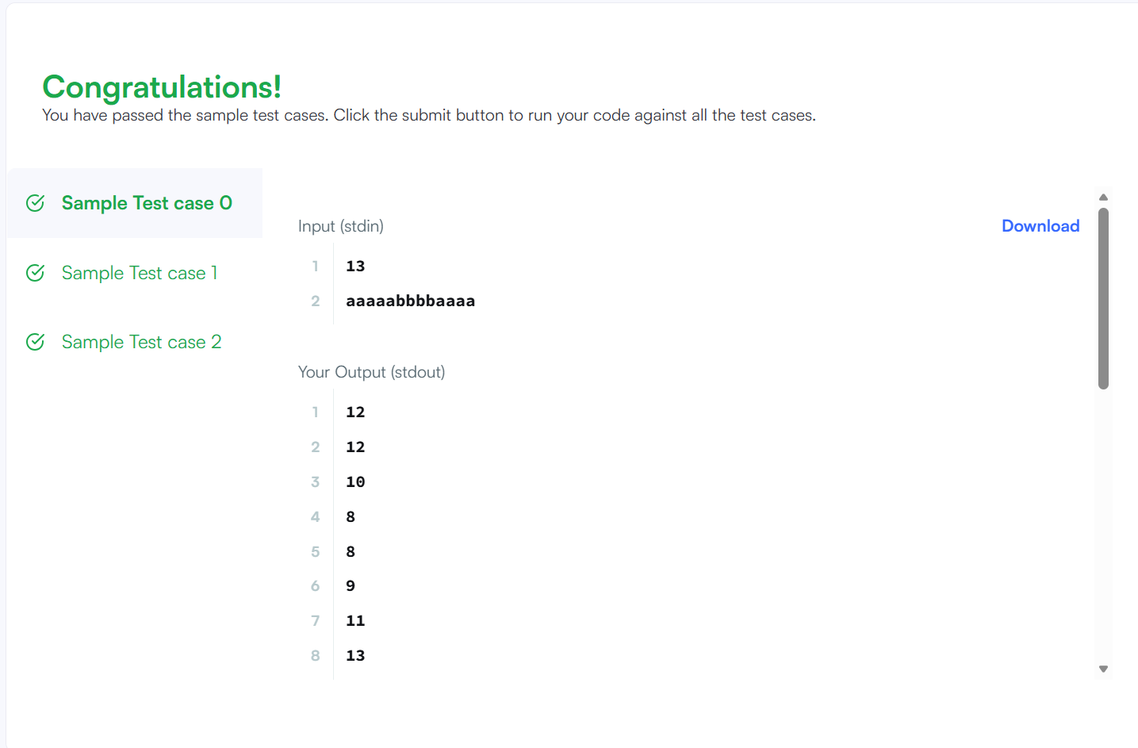

RESULT :
The program successfully prints the length of the longest palindromic substring for every rotation of the given string.

